**ANSWER KEY REVIEW 6th TIME- GRADE 5**

**Part 1:**

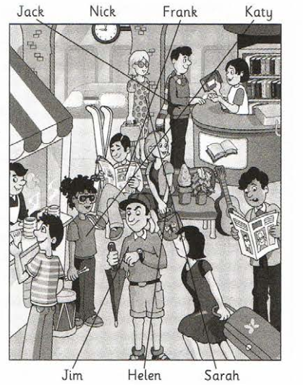

**Part 2:**

1. What did you eat?

2. Where did Henry and Andy have lunch?

3. Why did Max buy ten postcards?

4. Where did they find the money?

5. What did you learn about rocks and plants?